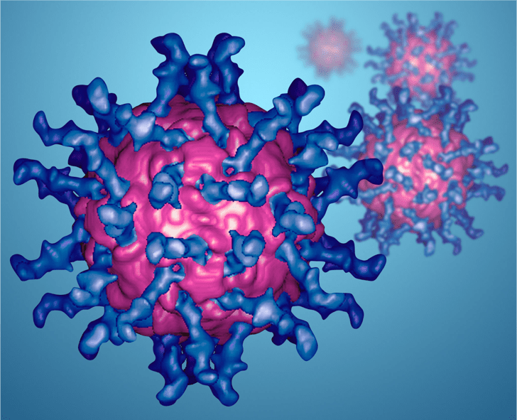  Best Practices for Emerging Infectious Diseases  Virtual Panel Discussion  March 30, 2026  10:00am-11:00am  No registration Required  Best Practices Panel Discussion Link  Join hospice and palliative care providers from across the state for an infectious disease best practices panel discussion featuring industry experts.  Discussion Points:  - Staff education and training  - Infection prevention during home visits  - PPE availability in the field  - Symptom identification and reporting  - Infection control policies  The Hospice and Palliative Care Association of New York State (HPCANYS) is conducting this emergency preparedness presentation as part of a series of activities funded by a grant from the Administration for Strategic Preparedness and Response (ASPR) and administered by the New York City Department of Health and Mental Hygiene (NYC DOHMH), Office of Emergency Preparedness and Response (OEPR). Its content is solely the responsibility of the authors and does not necessarily represent the official views of the Department of Health and Human Services' Administration for Strategic Preparedness and Response.  To replace any tip text with your own, just tap it and start typing. To replace the photo or logo with your own, on the Insert tab of the ribbon, just select the option you need.
  Panelists
  Joyce Palmieri MS, RN, CHPN, FPCN
  SVP of Hospice and Palliative Care Clinical Services, Metropolitan Jewish Health Services
  Geri Manginello RN
  Director of Regulatory Affairs, Hospice Care Network
  Deborah Walker MA, ANP-BC, ACHPN, NPD-BC
  Director, Clinical Professional Development, Northwell Health
  Charles Tilley PhD, ANP-BC, ACHPN, CWOCN, CHSE
  Educator, Calvary Hospice
  Nicole Golding MS, RN, AGNP-BC, ACHPN
  Director of Provider Operations, Hospice and Palliative Care Buffalo
  
  HPCANYS

